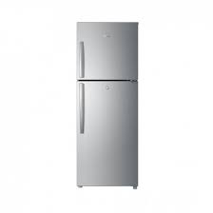

Haier (336EP)

* Faster Cooling & Freezing
* Voltages 125v~260v
* Color Grey
* Capacity 12 Cft
* **Rs.52,500**